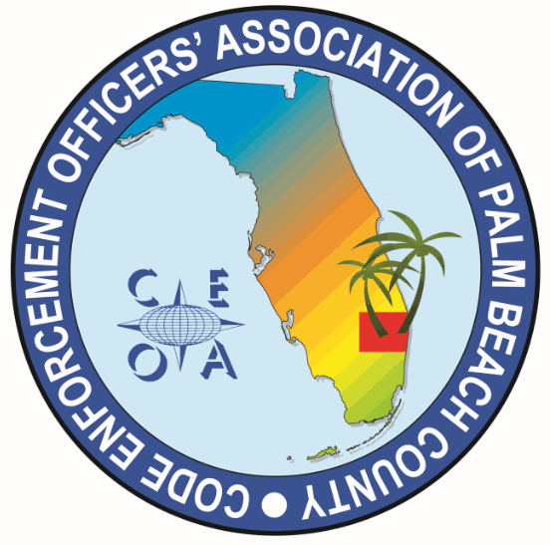
CODE ENFORCEMENT OFFICERS ASSOCIATION OF PALM BEACH COUNTY
BOARD MEETING AGNDA
FEBRUARY 12, 2025
11:30 AM
EATALIA
7750 OKEECHOBEE BLVD WEST PALM BEACH, FL 33411

CALL MEETING TO ORDER, ROLL CALL, ESTABLISH A QOURUM
APPROVAL OF MEETING MINUTES FROM OCTOBER 24, 2024
TREASURER REPORT – Joe Oliva

OLD BUSINESS

- VACANT BOARD POSITIONS/BOARD POSITION RESPONSIBILITIES
- CONSIDERATION OF APPOINTMENTS OF TWO VACANT POSITIONS AND APPOINTMENT OF A NEW VICE PRESIDENT PRIOR TO ELECTION

NEW BUSINESS

- MARCH 27TH ANNUAL MEETING, ELECTIIONS AND TRAINNG
- 11:00 AM LUNCH FOR MEMBERSHIP/RSVP NEEDED
- 12:00 PM PROCEDURE AT THE ANNUAL MEETING AND ELECTIONS
- 1:00 PM TO 3:00 PM TRAINING

- F.A.C.E. CONFRENCE SPONSORSHIP, DONATIONS, TABLE RAFFLE DISCUSSION
- BUILDING OFFICIALS ASSOCIAITON ANNUAL PICNIC.
- ATTENDANCE/SPOSORSHIP CONSIDERATION
- PARTNER FOR FUTURE TRAINING
- FUTURE TRAIINING SPEAKERS TOPICS AND LOCATIONS
- ITEMS TO BE CONSIDERED AT OUR NEXT BOARD MEETING
- SET MEETING DATE

ADJOURNMENT

.

